Progress Report 1
Due Date: Monday, 11 August 2025, 9:00 AM
COIT13236: Cyber Security Project (HT2, 2025)
Project: Secure Hybrid Network for SME First Aid Training Centre – VitalSkills
Group: G01-DST-UG25T2
Mentor: Sunil Seneviratne
Student1: Kenneth Christian (S0283279)
Student2: Fan Zhang (12035271)
Student3: Carl Khyncer Bhryn, YURONG (12224629)
Student4: Chris Bruhn (12195842)

1. GitHub Repository Link
https://github.com/cquict2025/nis-y25t2-project-g01-dst-ug25t2.git
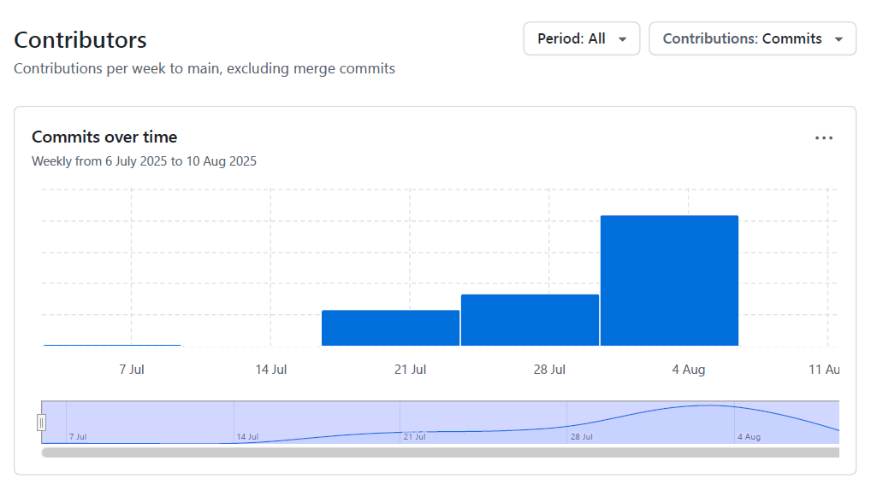

2. Technical Progress Since Project Start
Since the beginning of the project, the team has established a private GitHub repository and Microsoft Teams channel for collaboration, implemented a GitHub Kanban board to track progress, and completed several major deliverables. We have developed multiple security and system administration policies, designed a hybrid network integration strategy for on-premises and Azure environments, conducted risk analysis, and produced incident response documentation. Physical networking equipment was sourced and tested, while initial cloud concept configurations were set up and validated.
We have successfully completed the network simulation and testing in Cisco Packet Tracer, validating VLAN configurations, IP addressing schema, and inter-VLAN routing connectivity as per the project design.
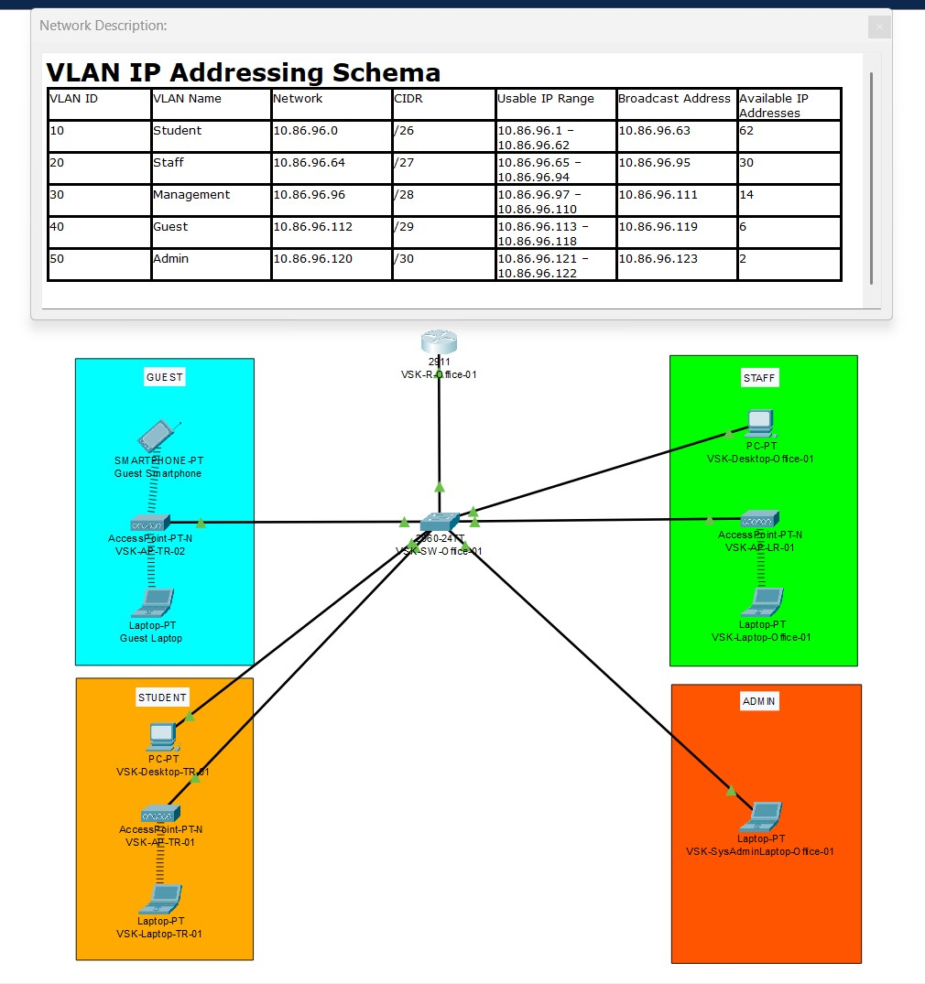
We have successfully completed the Azure cloud concept setup and testing, deploying and verifying the functionality of the virtual machines (VSADP01, VSEXP01, and VSFSP01) as part of the project’s cloud integration component.
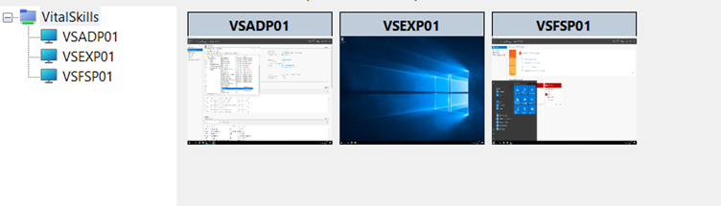
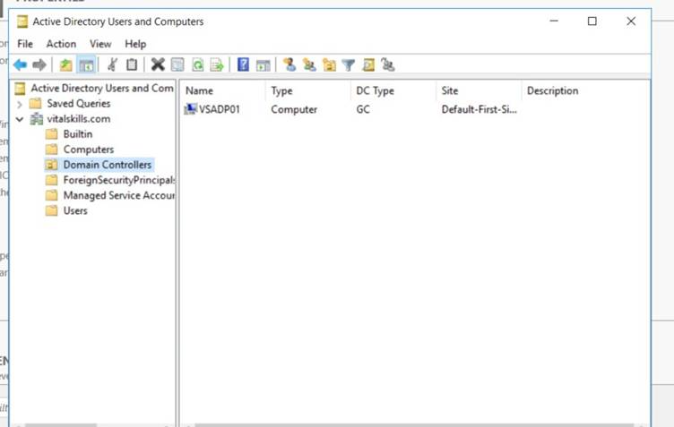

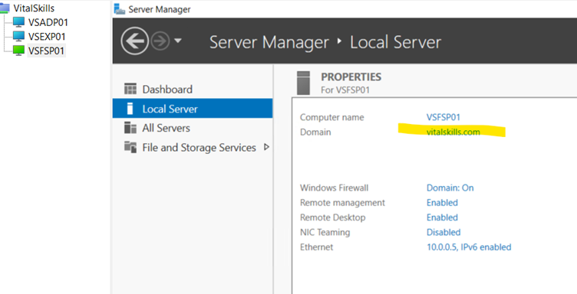
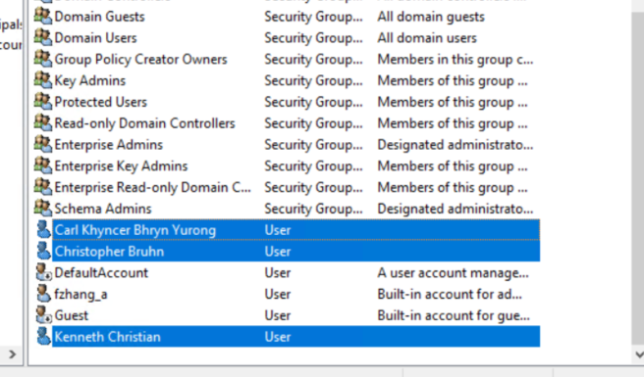

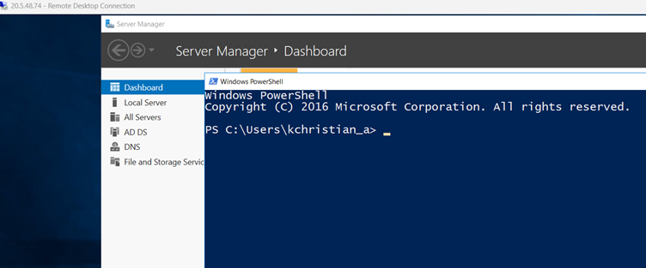
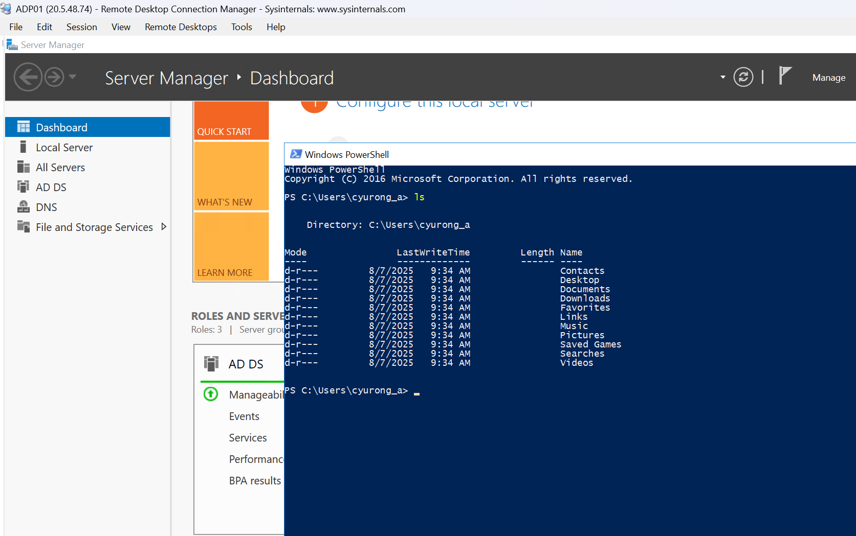

3. Individual Contributions

Since the start of the project, each member has contributed to key technical artefacts and deliverables. Ken coordinated with the local university campus to secure necessary networking hardware, a contribution that greatly accelerated the project’s design phase and ensured timely access to critical equipment. He also authored the Cyber Incident Response Plan, outlining detailed procedures for detection, containment, eradication, and recovery from potential security incidents. Christopher Bruhn produced the Cloud Integration Strategy and authored major policies covering Cloud Service Provider Management, Firewall Rule Sets & ACLs, Mobile Device Management, Software Management, and Third-Party Risk Management, as well as drafting the Project Requirement Specification. Carl completed the Risk Analysis and Security Policies, enhanced VitalSkills’ business specifications, refined stakeholder requirements and organizational Mission/Vision statements, and produced overviews for Risk Analysis, Cyber Incident Response, NIST 800-30, and the NIST Policy Integration Roadmap. He also contributed to a range of policy and management areas, including Education, Privacy, Risk Communication, Identity, Physical Security, Vulnerability, System Protection, Access, and Password Management. Fan developed several security and management policies, including Privileged Account, Data, Configuration, Asset, and Email Management, while also handling equipment setup, network configuration testing in Cisco Packet Tracer, cloud concept setup and validation, and the design of the network addressing scheme, VLANs, and DHCP pools, along with creating and testing router and switch configurations.

Individual Contributions Table
Team Member | Technical Artefacts Contributed | Description of Contribution
Christopher Bruhn | Cloud Integration Strategy | Document outlining hybrid network integration design (on-premises + Azure)
Christopher Bruhn | Cloud Service Provider Management Policy | Policy for managing CSP relationships and SLAs
Christopher Bruhn | Firewall Rule Set & ACL Configuration | Firewall configuration and access control documentation
Christopher Bruhn | Mobile Device Management Policy | Controls for mobile devices in SME environment
Christopher Bruhn | Software Management Policy | Software deployment, patching, and licensing procedures
Christopher Bruhn | Third-Party Risk Management Policy | Vendor and partner risk assessment and security requirements
Christopher Bruhn | Project Requirement Specification | Defined scope, requirements, and deliverables for project
Carl | Risk Analysis | Threat identification, likelihood assessment, and mitigation strategies
Carl | Security Policies | Baseline SME security framework
Carl | Business Specifications Enhancements | Suggestions to improve VitalSkills’ business specifications, refine Mission/Vision, define stakeholder requirements and headcount allocations
Carl | General Overviews of Key Components | Drafted overviews for Risk Analysis, Cyber Incident Response, NIST 800-30 Risk Analysis framework, NIST Policy Integration Roadmap
Carl | Policy & Management Area Coverage | Authored or contributed to: Education Management, Privacy Management, Risk Communication, Identity Management, Physical Security Management, Vulnerability Management, System Protection Management, Access Management, Password Construction
Ken | Hardware Liaison | Coordinated with local university campus to provide networking equipment for project
Ken | Cyber Incident Response Plan | Documented procedures for detection, containment, eradication, and recovery from cyber incidents
Fan | Privileged Account Management Policy | Created policy outlining controls and monitoring for privileged accounts in hybrid network environment
Fan | Data Management Policy | Guidelines for secure storage, classification, retention, and disposal of SME data
Fan | Configuration Management Policy | Documented standards for system configuration and change management
Fan | Asset Management Policy | Asset inventory creation and lifecycle tracking
Fan | Email Management Policy | Secure usage, monitoring, and retention of business email
Fan | Testing the equipment setup | Configured and tested physical networking equipment provided for project
Fan | Testing configurations in Packet Tracer | Built and validated network configurations in simulation prior to deployment
Fan | Cloud concept setup and testing | Deployed and tested proof-of-concept Azure hybrid integration
Fan | Network addressing scheme, VLANs, and DHCP pools design | Designed and implemented network addressing, VLAN segmentation, and DHCP pools for SME network
Fan | Router and Switch Configuration | Created and tested router and switch configurations for hybrid network deployment

4. Project Task Completion Status
Phase | Task | Dependencies / Status
Planning Phase Week 1-2 | Requirement Gathering & Client Consultation ✅ | None ✅
Planning Phase Week 1-2 | Site Layout ✅ | Requirement Gathering ✅
Planning Phase Week 1-2 | Zone Mapping ✅ | Site Layout ✅
Design Phase Week 3 | Wi-Fi Network Design ✅
Design Phase Week 3 | VLAN and Subnet Design ✅ | Wi-Fi Network Design ✅
Design Phase Week 3 | Physical Network Topology | ✅
Development Phase Week 4-5 | Router Configuration ✅
Development Phase Week 4-5 | Firewall and ACL Setup | Router Configuration ✅
Development Phase Week 4-5 | DHCP and DNS Setup ✅ | Router Configuration ✅
Development Phase Week 4-5 | Cloud Service Integration (Concept)✅
Development Phase Week 4-5 | VPN Implementation ✅ | Cloud Service Integration ✅
Development Phase Week 4-5 | Network Configuration Deployment | Firewall and ACL Setup, DHCP and DNS Setup ✅, VPN Implementation ✅

5. Issues and Challenges
Issue/Challenge | Impact | Action/Approach
Time constraints due to overlapping academic, project, and work commitments (3 out of 4 members working full-time) | Limited real-time collaboration between team members and slower task turnarounds during weekdays | Increased use of asynchronous communication via Teams, regular updates on GitHub, and clearly assigned responsibilities on the Kanban board
Azure student subscription limitations | Maximum of three VMs per resource group, restricting simultaneous testing environments | Scheduled testing windows, used local lab equipment for VLAN, DHCP, and routing tasks, and stored VM configurations for quick redeployment
No firewall hardware available on campus | Prevented on-site firewall configuration and testing | Consult with mentor regarding firewall options and possible simulation or cloud-based alternatives
Azure setup complexities | Slowed hybrid cloud integration testing | Broke down Azure setup into smaller configuration stages and cross-verified settings against Azure documentation

6. Priority Tasks for Next Phase
Task | Assigned To
Firewall & ACL Hardening | Carl
Risk Assessment & Validation | Carl
Vulnerability Testing | Carl
Security Checklist Finalization | Carl
Mitigation Plan Creation | Carl
WLC into the Packet Tracer | Fan
Security Hardening | Chris
Functionality Testing | Chris
Performance Testing | Ken
Risk Assessment and Mitigation | Ken
Documentation and User Guide | Chris
Defect Resolution | Ken
Prototype Demonstration | Fan
Azure setup and Implementation | Everyone

